

Homework 5

Ant Colony Optimization

Advanced Algorithm

Supervisor:

Dr. Ziarati

Atefe Rajabi

40230563

Spring 2024

Index

Introduction

ACO

2D Bin Packing

Literature Review

Fitness calculation

Parameters

Implementation Details

Representation

Constructing Solution

State transition

Rectangle Placement

Heuristic Information

Pheromone Updating

Pheromone Graph

Results

Plots

Discussion

Conclusion

Introduction

In the realm of combinatorial optimization, certain problems challenge even the most advanced computational strategies due to their complexity and the computational expense involved in finding optimal solutions. The 2D bin packing problem is a classic example of such challenges, where the goal is to efficiently pack items into bins with limited space, minimizing the number of bins used. This problem finds practical applications in industries ranging from logistics and manufacturing to software design and resource allocation.

To tackle such intricate problems, researchers have turned to nature-inspired algorithms, which mimic natural processes to solve optimization problems. One of the most effective and popular of these is the Ant Colony Optimization (ACO) algorithm. This algorithm, inspired by the foraging behavior of ants, has been successfully applied to a variety of optimization problems, including the 2D bin packing problem. This document explores the application of ACO to the 2D bin packing problem, detailing the methodology, implementation, and results of this approach.

Ant Colony Optimization (ACO)

Ant Colony Optimization is a probabilistic technique used in computing for finding optimized paths through graphs. Simulating the behavior of ants searching for food, ACO is adept at solving complex problems that can be reduced to finding good paths through graphs. Initially proposed by Marco Dorigo in 1992 in his PhD thesis, ACO has since been applied to a wide array of optimization problems.

In ACO, artificial 'ants' (simple computational agents) simulate the expedition of ants walking from their colony to food sources and back. These artificial ants deposit a substance called pheromone on the paths they traverse, which influences the path selection of subsequent ants. Over time, shorter paths receive higher concentrations of pheromone and are thus more likely to be chosen, leading the colony as a whole to the best solutions.

2D Bin Packing Problem

The 2D bin packing problem is a classic problem in computational mathematics and operations research where the objective is to pack a set of two-dimensional objects into the smallest number of rectangular bins or containers as efficiently as possible. Each object and bin can be rotated by 90 degrees, adding a layer of complexity to the problem. The challenge lies in both the arrangement and orientation of these items to minimize the wasted space and number of bins used.

This problem is NP-hard, meaning there is no known polynomial-time algorithm to find an optimal solution for all possible cases. As such, it is typically approached with heuristic or approximation algorithms, which yield good solutions within a reasonable timeframe.

Literature Review:

“Space Splitting and Merging Technique for Online 3-D Bin Packing”[1] introduces a novel approach to online 3-D bin packing using a space splitting and merging technique, addressing the challenge of packing in real-time without prior knowledge of incoming items. By dynamically dividing the bin into main and secondary spaces, the method optimally allocates space for new boxes, enhancing packing efficiency. The algorithm employs a dual data structure system to expedite the search for fitting spaces, thereby reducing computational overhead and response times. Additionally, merging underutilized spaces minimizes spatial fragmentation, further optimizing packing density. Overall, this technique significantly improves the solution construction process in automated packing systems, crucial for industries like logistics and e-commerce.

In the document "Ant Colony Optimization for Bin Packing and Cutting Stock Problems,"[2] the authors explore updating pheromone levels in the context of Ant Colony Optimization (ACO) for solving NP-hard problems. Pheromones in ACO algorithms simulate the stigmergic communication used by ants in nature, guiding the collective toward efficient solutions by marking successful paths with pheromone trails. In the specific application to bin packing and cutting stock problems, the pheromone update process is crucial. After ants’ construct solutions, pheromones are deposited on paths that represent good decisions, i.e., combinations of items that effectively minimize the space or number of bins used. The amount of pheromone deposited is inversely proportional to the quality of the solution; better solutions result in more pheromone, which in turn guides future iterations of the algorithm towards these promising regions of the solution space. This updating process ensures that over time, the probability increases that more ants follow paths leading to better solutions, optimizing the overall search process and convergence towards the best solution.

In "Study on Improved Ant Colony Optimization for Bin-Packing Problem,"[3] the bin packing problem (BPP) is transformed into a graph for effective Ant Colony Optimization (ACO) algorithm application. Items are represented as nodes, and potential packing actions are depicted as edges where pheromones can be deposited. This graph-based representation aids in visualizing the BPP as a search for an optimal path that maximizes item packing within bin constraints. The ACO algorithm utilizes pheromone trails on these graph edges to guide ants in searching for the most effective packing sequences, with pheromone strength reflecting the quality of packing solutions. Ants make probabilistic choices based on both the pheromone levels and heuristic data, such as item size and remaining bin space. Over iterations, pheromone updates on the graph's edges enhance the mapping of items to bins, aiming to minimize the number of bins used or maximize space utilization.

Fitness Function:

The objective_function calculates the overall fitness of a list of container bins. For each container (bin), it accumulates the fitness value obtained from calling get_fitness on that container. The fitness of each container is calculated as the square of the ratio of the filled area (total_area - available_area) to the total area of the container (width * height). This squaring emphasizes differences in packing efficiency. The objective function then returns the inverse of the average fitness across all containers, calculated as 1 - (bins_fitness / len(containers)). This means that a higher average fitness (i.e., more space filled in each container) results in a lower objective value, aiming to minimize this value to improve packing efficiency.

Parameters:

1. alpha: This parameter controls the influence of pheromone trails on the probability of selecting a particular path, emphasizing the role of accumulated experience.

2. beta: This parameter dictates the importance of heuristic information (like the quality or suitability of a path) in the decision-making process.

3. evaporation_rate: This sets the rate at which pheromone trails evaporate or diminish over time, helping to reduce the influence of outdated paths.

4. ant_count: Specifies the number of ants used in the simulation, determining the breadth of solution exploration.

5. max_iteration: Limits the number of iterations the algorithm will execute, defining the end condition of the algorithm.

6. elit_percent: Represents the percentage of the best performing ants that are allowed to deposit extra pheromones, enhancing the reinforcement of successful paths.

9. max_pheromone: Establishes the upper limit of pheromone concentration on a path, preventing any path from becoming disproportionately attractive.

10. min_pheromone: Sets the minimum pheromone level that any path can have, ensuring that no path becomes entirely unattractive.

11. ACS_state_transition_prob: In the Ant Colony System (ACS) variation, this is the probability threshold that dictates whether ants choose their next step based on a deterministic or exploratory process, balancing exploitation and exploration.

Implementation Details:

Representation:

In the context of graph representation for solving combinatorial optimization problems such as Bin Packing, each item in the problem is represented as a node within the graph. The edges between these nodes are weighted with pheromone levels, which play a critical role in the Ant Colony Optimization (ACO) algorithm. This pheromone acts as a form of indirect communication among the ants (agents in the ACO algorithm), which guides their search towards more promising regions of the solution space. Specifically, the pheromone levels on the edges increase as more ants follow that path, indicating a potentially better solution. Over time, this results in a higher probability of the path being chosen by other ants, thereby reinforcing successful solutions and gradually leading to the optimal or near-optimal solutions to these NP-hard problems.

Constructing Solution:

1. ‘LF_construct_solution’:

- Purpose: Constructs a packing solution using the Last Fit where each item is placed in the most recently utilized container that can accommodate it. If the item cannot be accommodated by this container, a new container is initiated.

- Process:

- Starts by initializing a list with one empty container and copies the list of rectangles to be placed.

- Places the first item in the initial container and sets it as the current item.

- Iteratively selects the next item based on the ‘ACS_state_transition’ function, which likely considers pheromone trails to determine the placement sequence.

- Attempts to place the selected item in the last used container. If it doesn't fit, a new container is created and the item is added there.

- Continues this process until all items are placed in containers, using the most recent container when possible to adhere to the Last Fit strategy.

2. ‘FF_construct_solution’:

- Purpose: Constructs a packing solution using a first fit approach, where the next item is placed in the first available container that can accommodate it.

- Process:

- Begins with one container.

- Iteratively places each item into the first container that has enough space.

- If none of the existing containers can accommodate the item, a new container is initiated.

Ant's Construction of a Solution

Each ant in the colony constructs a solution by sequentially placing rectangles into containers. The process involves a state transition function ‘ACS_state_transition’, which selects the next item to place based on both the pheromone levels and heuristic information (packing larger items into the bin with the least available space)

- Start with an empty container and a list of all rectangles.

- The first item is selected randomly.

- The ant attempts to place the selected rectangle in a container according to the strategy defined (Last Fit).

- If the rectangle does not fit in any existing container, a new container is opened.

- Continue the process by selecting the next rectangle using the state transition function, which considers both the pheromone trails and the heuristic values.

- Place each subsequent rectangle using the defined strategy, updating containers as needed.

- The process repeats until all rectangles are placed.

- The solution consists of the number of containers used and their contents.

Heuristic Information:

In the context of the Ant Colony Optimization (ACO) algorithm applied to bin packing problems, heuristic information eta_ij can be strategically defined to guide the placement of items into bins. The formula eta_ij = (s_i / r_j)beta is used, where s_i represents the size of the item to be placed, and r_j is the remaining capacity of bin j before placing the item. This heuristic emphasizes placements where the item fits snugly within the bin, minimizing wasted space and encouraging efficient use of bin capacity. The parameter beta adjusts the sensitivity of the heuristic to the proportion of the item size to the remaining bin capacity. A higher value of beta enhances the preference for tighter fits, which can lead to more optimal packing configurations by prioritizing the placement of larger items into bins with just enough space to accommodate them. This approach leverages the inherent characteristics of the items and bins to make informed and effective decisions during the solution construction phase of ACO, aiming to achieve densely packed bins and potentially reduce the total number of bins used.

State transition:

In the Ant Colony Optimization (ACO) algorithm, especially in variations like Ant System (AS) and Ant Colony System (ACS), state transition functions dictate how ants choose the next node (or component in the context of problems like 2D bin packing) to visit. These functions are critical for balancing exploration and exploitation, two key aspects of any optimization algorithm.

1. **Random Proportional Rule (used in AS):** This rule is typically used in the original Ant System. It combines the pheromone trail intensity and the heuristic information to probabilistically determine the next node to visit. The probability of choosing a specific node is proportional to a function of the pheromone level on the edge leading to that node raised to the power of alpha, multiplied by a heuristic factor (like visibility or closeness) raised to the power of beta. This function ensures that paths with higher pheromone levels and better heuristic values are more likely to be chosen, but still allows for exploration of less-traveled paths.
2. **Pseudo-random Proportional Rule (used in ACS)**: In the ACS variation, the state transition function is more sophisticated. It introduces a parameter, often called q0, which corresponds to the ACS_state_transition_prob. Here, a random number is compared to q0. If the random number is less than q0, the ant selects the next node deterministically based on the maximum product of pheromone intensity and heuristic value (exploitation). If the random number is greater than q0, the next node is chosen according to a probability distribution similar to the random proportional rule used in AS (exploration). This approach aims to achieve a better balance between exploiting known good paths and exploring potentially better but less-known paths. (This method has been used in the current project.)

Pheromone Update

After all ants have constructed their solutions, the pheromones on paths (here representing specific placements of rectangles into containers) are updated to reinforce more successful solutions (those using fewer containers). This guides future ants towards more promising areas of the search space, ideally leading to increasingly optimized solutions over the iterations.

1. update_pheromones_ACS Method:

The ‘update_pheromones_ACS’ method for updating pheromones in the Ant Colony System (ACS) focuses on evaporating pheromones initially and then reinforcing them based on a solution's performance. This two-step process starts with pheromone evaporation across all pairs of rectangles (or nodes), where pheromones are reduced by a factor dictated by the evaporation rate, ensuring no path remains indefinitely preferable. The diagonal elements are zeroed out to avoid self-loop enhancements. In the reinforcement phase, pheromones are increased for pairs of rectangles that coexist in the same container within a solution, with the increase amount inversely proportional to the solution's objective function score. This encourages ants to follow paths that have led to more efficient packing solutions. (This method has been used in the current project for updating pheromones)

1. update_pheromones_elitist Method:

The ‘update_pheromones_elitist’ method adjusts pheromones with a focus on elite solutions. Similar to ACS, it starts by evaporating pheromones to reduce the influence of older paths. The method then identifies a subset of elite solutions, which are the best-performing solutions in terms of the number of containers used. Pheromones are significantly reinforced along paths used by these elite solutions, with the increase calculated based on the inverse of the objective function, thus heavily promoting highly efficient configurations discovered by the top-performing ants.

1. update_pheromones_MMAS Method:

The ‘update_pheromones_MMAS’ method aligns with the Max-Min Ant System (MMAS) rules, focusing on strong exploitation of the best-found solutions while preventing convergence to a local optimum by maintaining a range between minimum and maximum pheromone levels. Initial steps involve evaporating pheromones to prevent over-exploitation of existing paths and enforcing a minimum pheromone level to keep all options available. Subsequently, pheromone reinforcement is exclusively based on the globally best solution found across all iterations, with increases limited by a specified maximum pheromone cap, ensuring that the reinforcement does not lead to premature convergence by making any path too dominant.

Rectangle Placement:

This module focuses on accommodating rectangles within a bin, managing unoccupied spaces efficiently, and visualizing the arrangement.

Space Class

- Purpose: Represents a rectangular unoccupied space within the bin.

- Attributes: Coordinates of the corners (‘x1’, ‘x2’, ‘y1’, ‘y2’), and the calculated width and height based on these coordinates.

Merging Functions

These functions merge adjacent unoccupied spaces to form larger contiguous spaces, reducing the complexity of space management.

- merge_horizontally(): Merges spaces that are aligned horizontally (same ‘y’ coordinates) and are adjacent (their ‘x’ boundaries touch).

- merge_vertically(): Merges spaces that are aligned vertically (same ‘x’ coordinates) and are adjacent (their ‘y’ boundaries touch).

Rectangle Placement

This is the core functionality of the module, where it tries to fit a new rectangle into the available unoccupied spaces.

- _place_rectangle_bin(): Tries to place a rectangle in the existing unoccupied spaces. If the rectangle fits, it updates the list of unoccupied spaces by adjusting the boundaries or splitting the existing space into smaller parts.

- place_rectangle(): Public interface that attempts to place the rectangle using ‘_place_rectangle_bin()’. If no suitable space is found, it invokes algorithms (‘RLSweepLine’ and ‘TBSweepLine’) to reevaluate and reorganize the unoccupied spaces for better fitting.

Right-to-Left Sweep Line Method for Space Optimization

The right-to-left sweep line method is an algorithm designed to efficiently manage and reorganize unoccupied spaces within a two-dimensional area, specifically to enhance the accommodation of tall items. This method employs a dynamic and systematic approach to analyze and partition available spaces based on their dimensions and positional relationships.

- Spatial Analysis: As the sweep line progresses from the rightmost edge to the leftmost edge of the container, it encounters and processes the boundaries of existing unoccupied spaces.

- Event-Driven Manipulation: Each space is associated with two events—'start' at the right boundary and 'end' at the left boundary. The ordering of these events is crucial, as it determines when spaces are activated or deactivated for consideration.

- Space Partitioning: When the sweep line reaches the 'end' of a space without aligning with its left boundary, the space may be split. This splitting is based on the current position of the sweep line, effectively dividing the space into two segments: one to the right of the line (which remains active and will be used for merging) and one to the left (which recursively undergoes further processing).

Advantages of Vertical Merging:

- Enhanced Vertical Space Utilization: By partitioning spaces as described, the algorithm optimally prepares them for vertical merging. This is particularly beneficial for the placement of tall items, as it creates taller, continuous vertical spaces free of horizontal interruptions.

- Improved Packing Density: This method reduces the fragmentation of space, allowing taller items to be placed more efficiently. By minimizing wasted space through strategic vertical merging, the overall packing density and organization of the area are significantly enhanced.

Top-To-Bottom Sweep Line Method for Space Optimization

The top-to-bottom sweep line method mirrors the functionality of the right-to-left sweep line approach but is tailored for optimizing space utilization for wide items. In this method, the sweep line moves from the top to the bottom of the container, systematically managing the horizontal expanses of unoccupied spaces. As the line encounters the upper and lower boundaries of these spaces, it triggers events—'start' at the upper boundary and 'end' at the lower boundary. This event-driven process ensures that spaces are considered active when the line enters them and are re-evaluated for splitting as the line exits. If a space's lower boundary does not align with the sweep line's current position, it may be split horizontally, creating separate upper and lower sections. This horizontal partitioning is key to preparing spaces for subsequent horizontal merging, which is particularly advantageous for placing wider items. By consolidating fragmented horizontal spaces into larger continuous areas, this method enhances the efficient utilization of space, enabling better placement of wide items and improving overall packing density within the container.

Pheromone Graph:

After applying the ACO algorithm to the problem and plotting the graph, each edge is shown with its pheromone value. The larger the pheromone value, the stronger the edge. Additionally, the distance between the nodes connected by each edge is reduced. Each cluster on the graph represents a bin, indicating the effectiveness of the ACO algorithm in solving the problem by adjusting the pheromone trail and using heuristic information.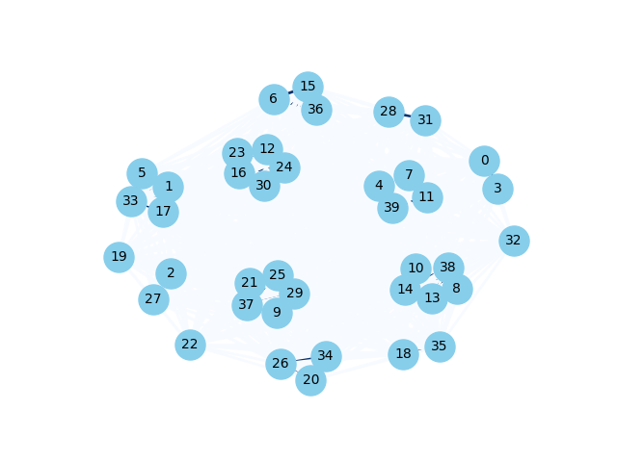

Results:

Results for 10 times of run

|  |  |  |
| --- | --- | --- |
| instance_name | Min | Max |
| cl_01_020_09.ins2D | 8 | 8 |
| cl_01_040_04.ins2D | 14 | 14 |
| cl_01_060_05.ins2D | 19 | 19 |
| cl_01_080_08.ins2D | 29 | 29 |
| cl_01_100_06.ins2D | 37 | 37 |
| cl_02_020_04.ins2D | 1 | 1 |
| cl_02_040_02.ins2D | 2 | 2 |
| cl_02_060_03.ins2D | 3 | 3 |
| cl_02_080_01.ins2D | 3 | 3 |
| cl_02_100_02.ins2D | 4 | 4 |
| cl_03_020_05.ins2D | 4 | 4 |
| cl_03_040_07.ins2D | 8 | 9 |
| cl_03_060_04.ins2D | 15 | 15 |
| cl_03_080_09.ins2D | 22 | 22 |
| cl_03_100_10.ins2D | 29 | 30 |
| cl_04_020_03.ins2D | 1 | 1 |
| cl_04_040_05.ins2D | 2 | 2 |
| cl_04_060_07.ins2D | 2 | 3 |
| cl_04_080_08.ins2D | 4 | 4 |
| cl_04_100_09.ins2D | 4 | 4 |
| cl_05_020_04.ins2D | 5 | 5 |
| cl_05_040_03.ins2D | 15 | 15 |
| cl_05_060_05.ins2D | 16 | 16 |
| cl_05_080_07.ins2D | 27 | 28 |
| cl_05_100_08.ins2D | 30 | 31 |
| cl_06_020_05.ins2D | 1 | 1 |
| cl_06_040_04.ins2D | 2 | 2 |
| cl_06_060_02.ins2D | 2 | 2 |
| cl_06_080_01.ins2D | 3 | 3 |
| cl_06_100_10.ins2D | 4 | 4 |
| cl_07_020_08.ins2D | 7 | 7 |
| cl_07_040_06.ins2D | 11 | 12 |
| cl_07_060_05.ins2D | 15 | 15 |
| cl_07_080_08.ins2D | 23 | 23 |
| cl_07_100_10.ins2D | 32 | 32 |
| cl_08_020_05.ins2D | 6 | 6 |
| cl_08_040_03.ins2D | 11 | 11 |
| cl_08_060_05.ins2D | 14 | 15 |
| cl_08_080_07.ins2D | 22 | 22 |
| cl_08_100_03.ins2D | 24 | 24 |
| cl_09_020_04.ins2D | 16 | 16 |
| cl_09_040_10.ins2D | 34 | 34 |
| cl_09_060_07.ins2D | 41 | 41 |
| cl_09_080_04.ins2D | 53 | 53 |
| cl_09_100_05.ins2D | 65 | 65 |
| cl_10_020_08.ins2D | 3 | 3 |
| cl_10_040_03.ins2D | 9 | 10 |
| cl_10_060_05.ins2D | 8 | 8 |
| cl_10_080_02.ins2D | 11 | 11 |
| cl_10_100_04.ins2D | 18 | 18 |

Variance and Mean:

The true answer line is based on a greedy algorithm calculation.

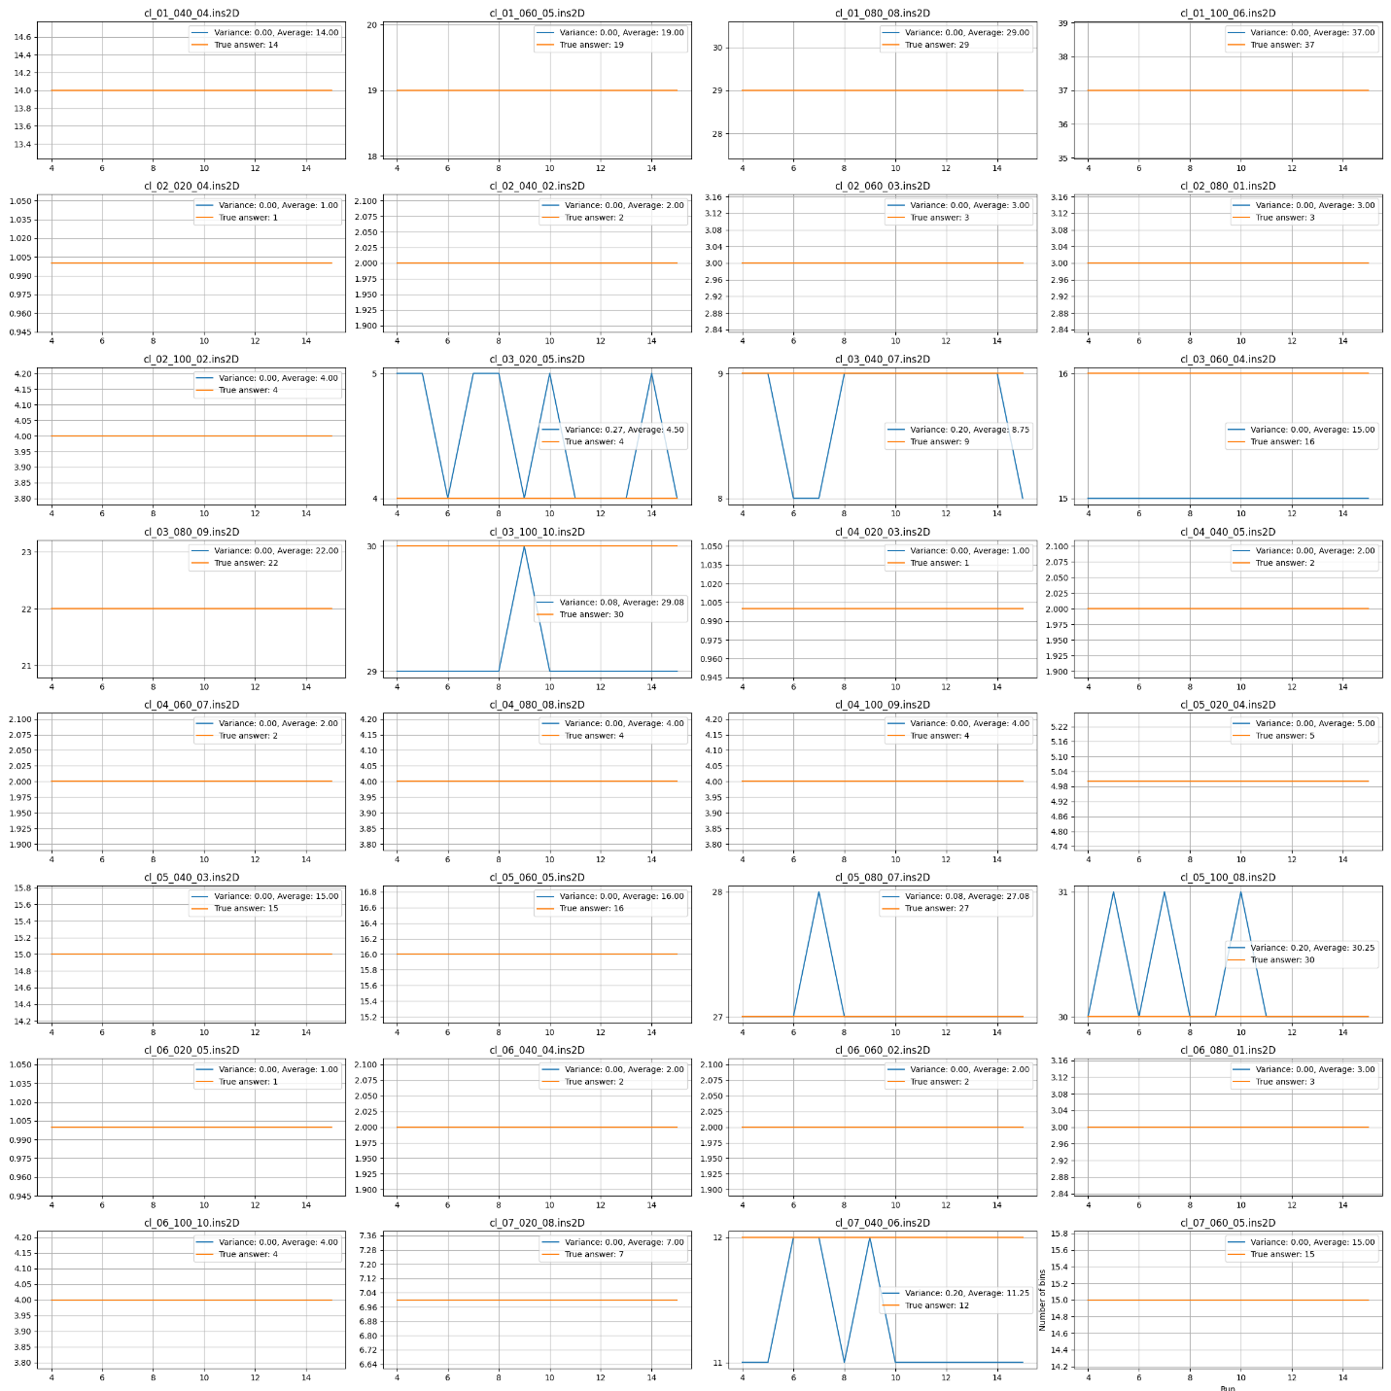

Plots:

An increase in the number of ants and a decrease in the ACS probability (using the pseudo-random technique in the ACO algorithm) indicate that there has been no improvement for several consecutive iterations. Therefore, by increasing the number of ants and decreasing the probability, the algorithm tries to explore more of the search space.

There is a minimum threshold for ACS probability, which is set at 0.7.

cl_1_020_09:

By increasing the number of ants and decreasing the ACS probability, we observed that a better solution was found after a few iterations, specifically by iteration 20, due to more extensive exploration.

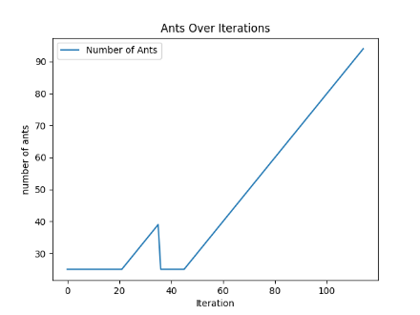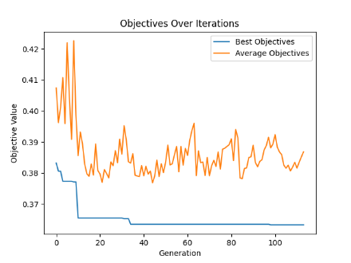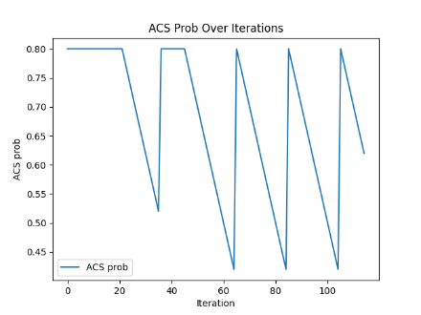

cl_01_040_04:

The instability in the Average Objectives for the current colony is due to increased exploration, which occurs as the algorithm is allowed to select more often based on the roulette wheel, given the decreasing ACS probability.

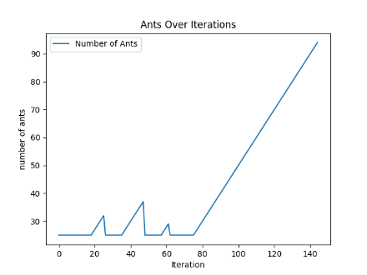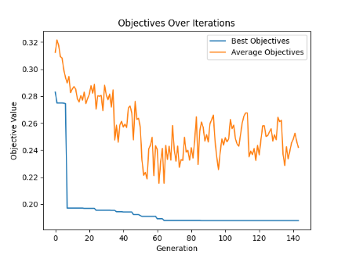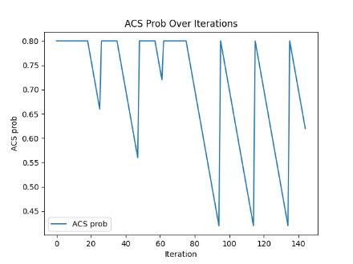

cl_01_060_05:

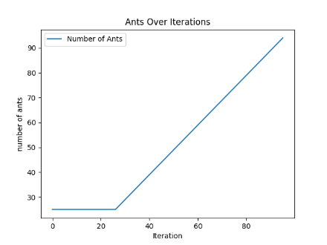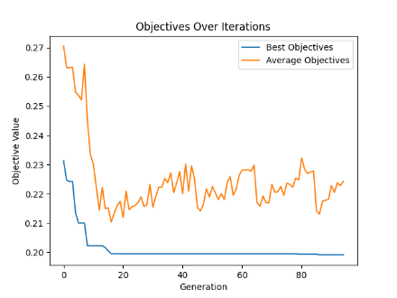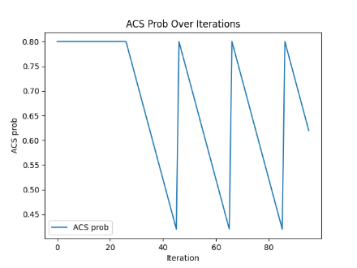

cl_01_080_08:

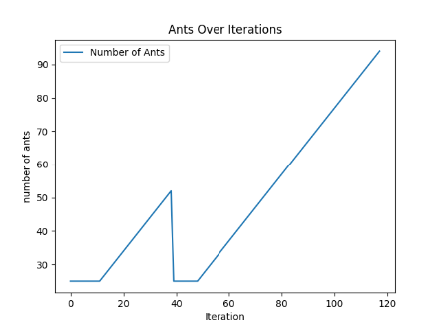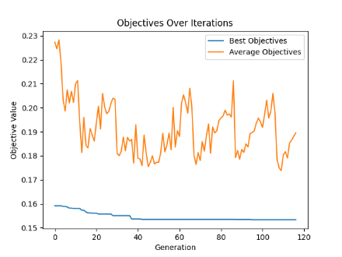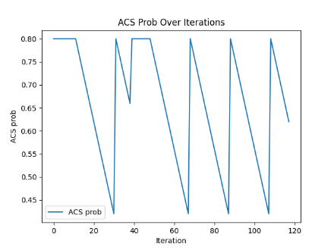

cl_01_100_06:

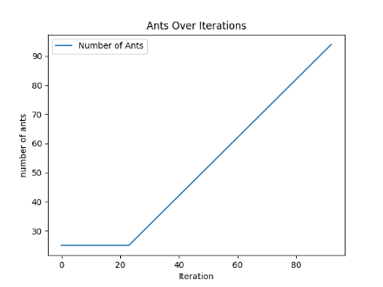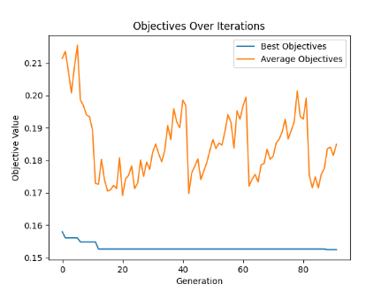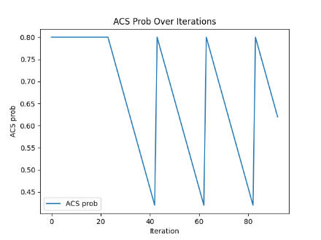

cl_02_020_04:

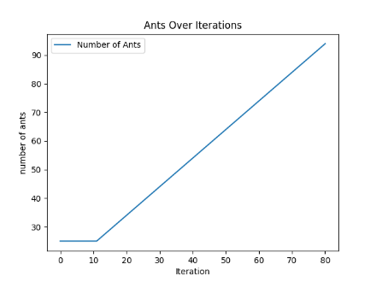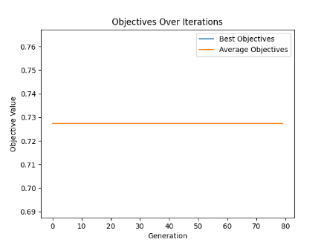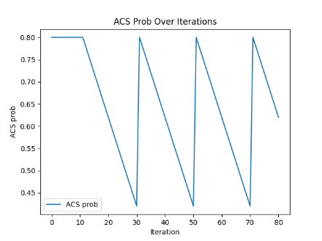

cl_02_040_02:

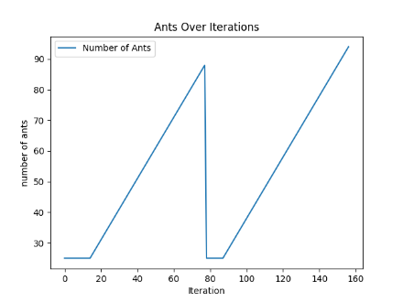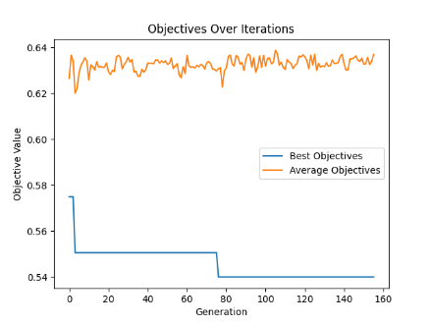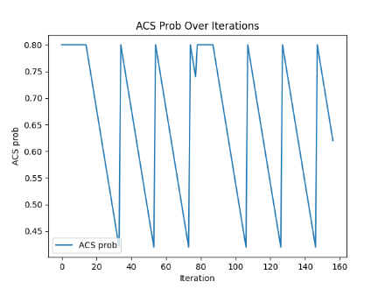

cl_02_060_03:

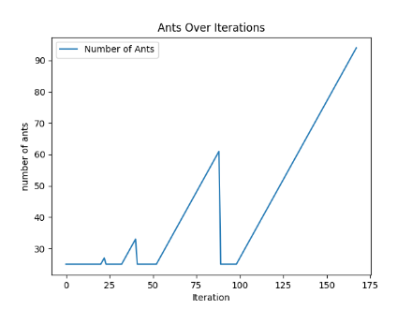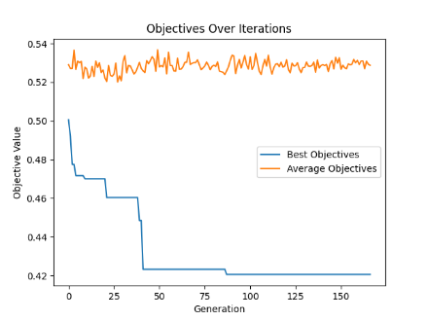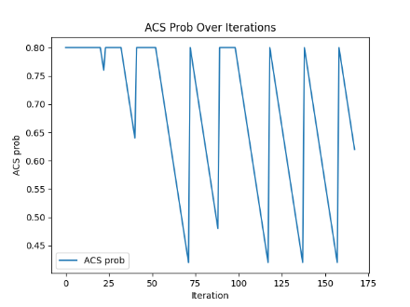

cl_02_080_01:

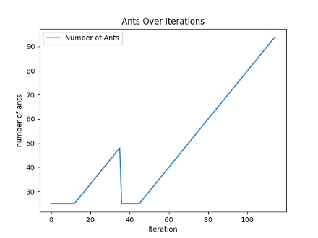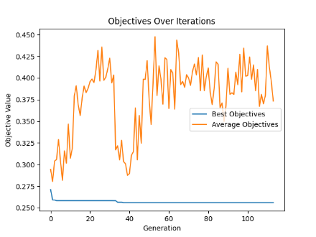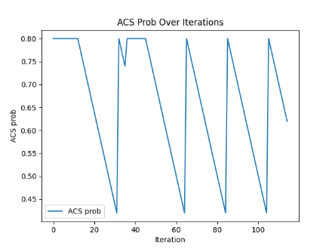

cl_02_100_02:

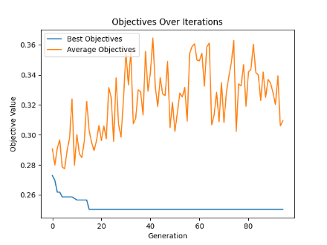

cl_03_020_05:

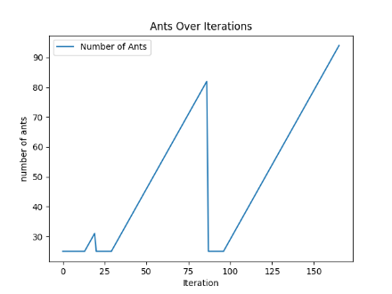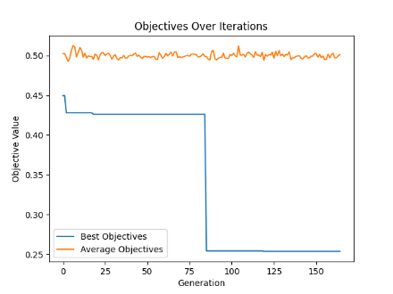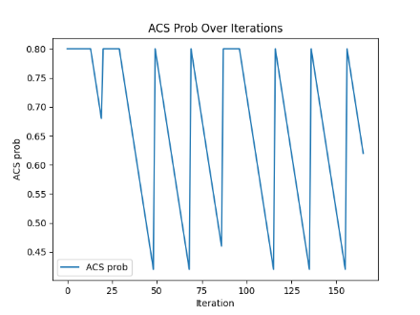

cl_03_040_07:

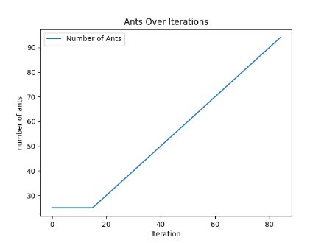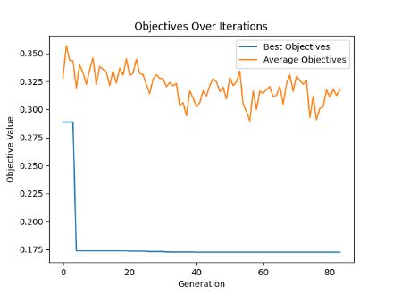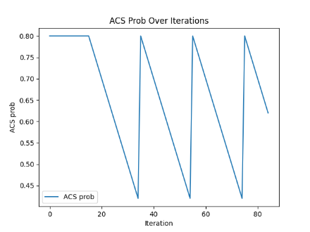

cl_03_060_04:

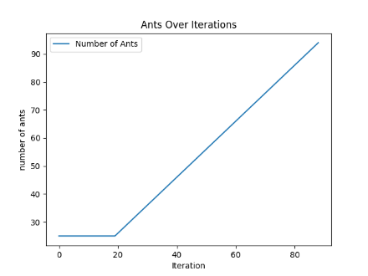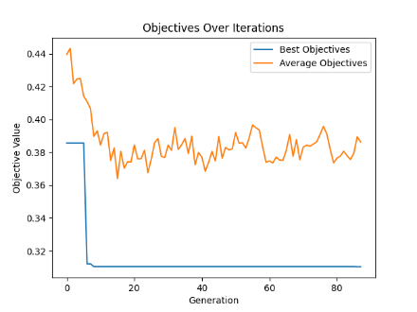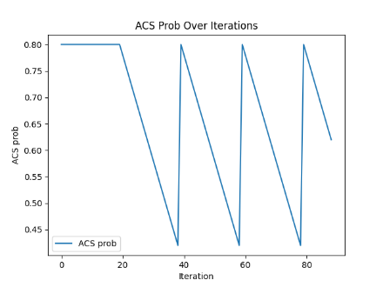

cl_03_080_09:

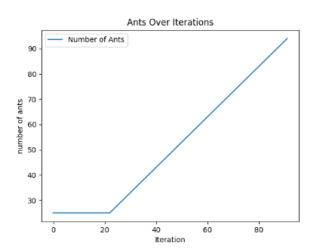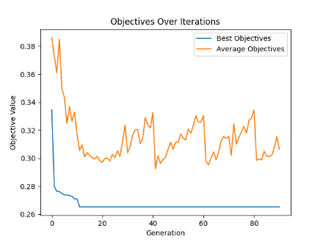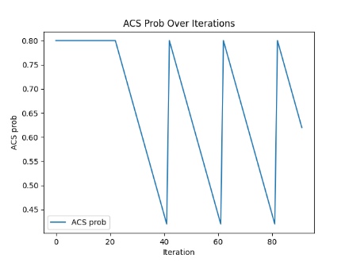

cl_03_100_10:

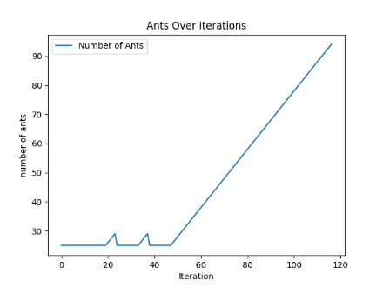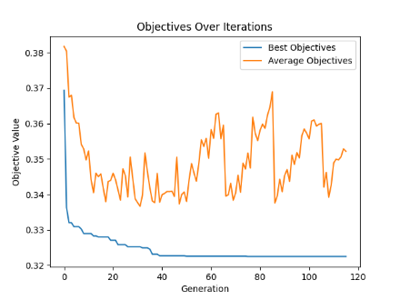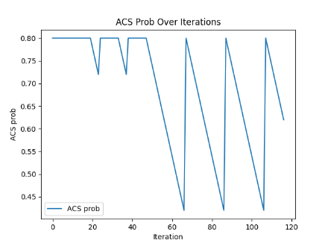

cl_04_020_03:

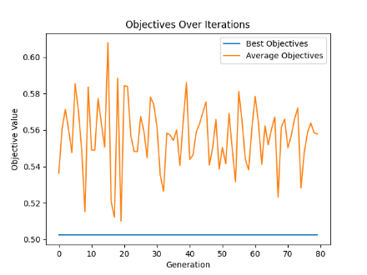

cl_04_040_05:

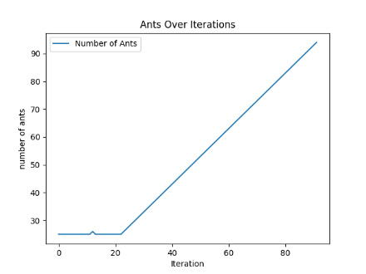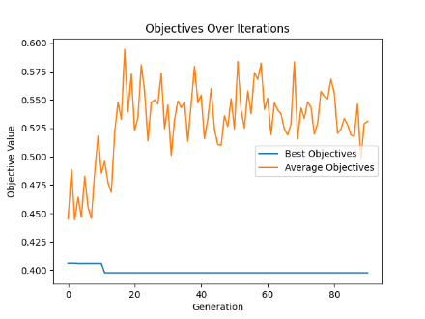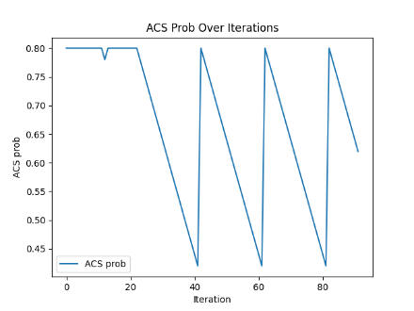

cl_04_060_07:

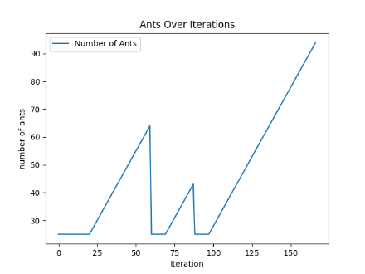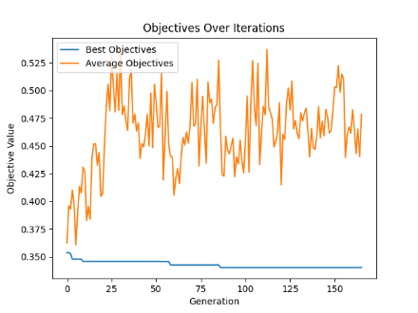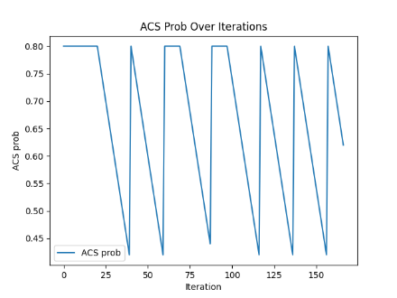

cl_04_080_08:

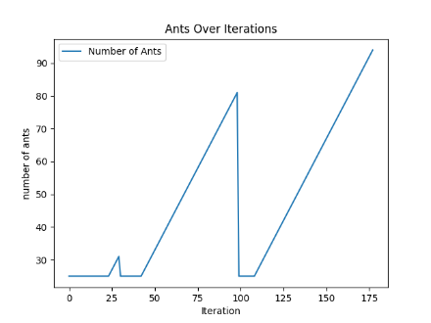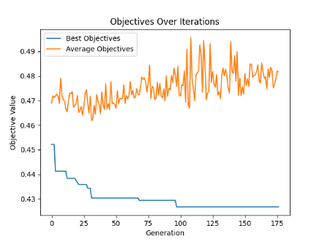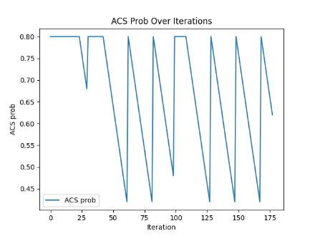

cl_04_100_09:

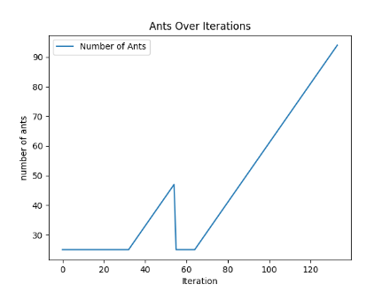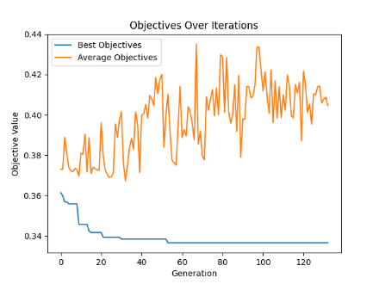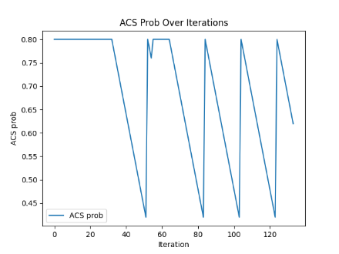

cl_05_020_04:

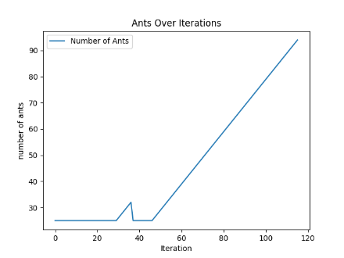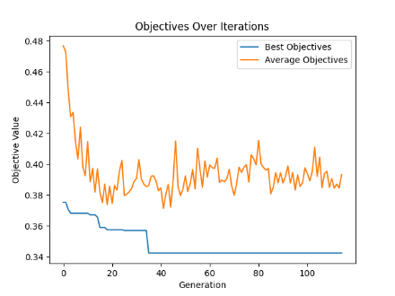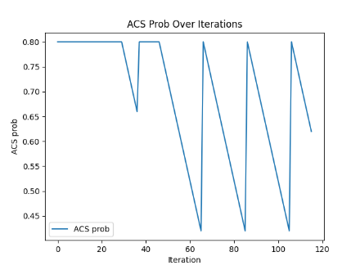

cl_05_040_03:

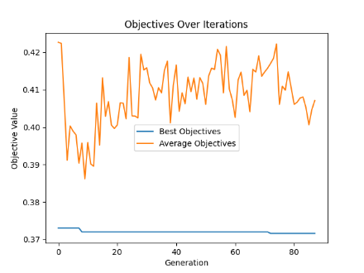

cl_05_060_05:

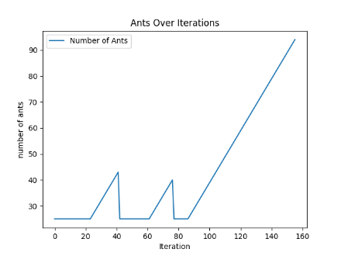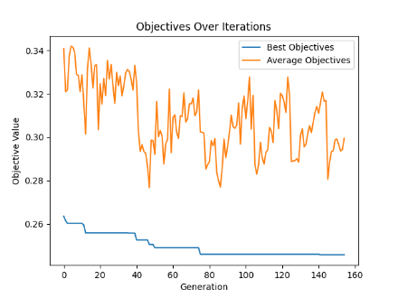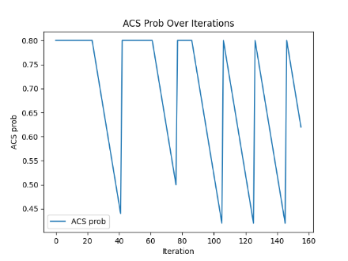

cl_05_080_07:

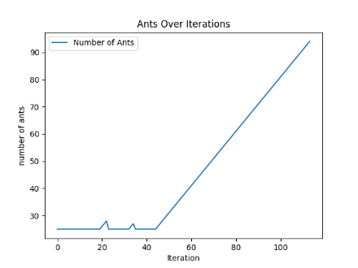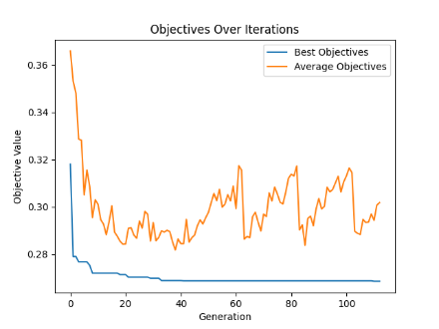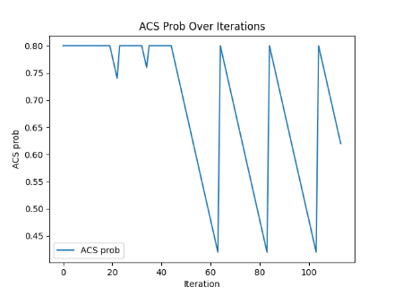

cl_05_100_08:

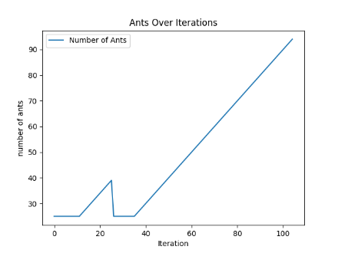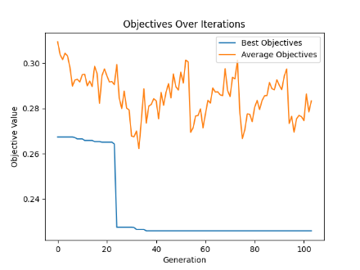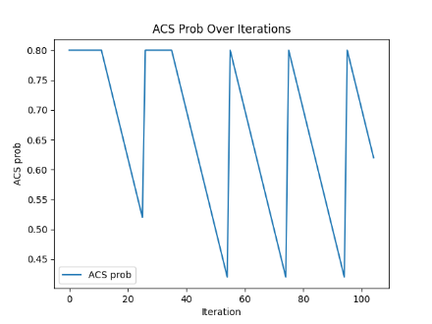

cl_06_020_05:

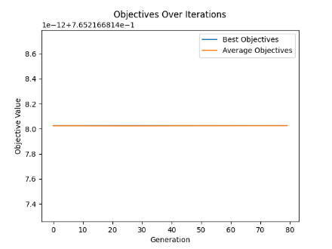

cl_06_040_04:

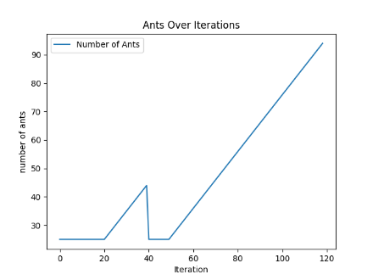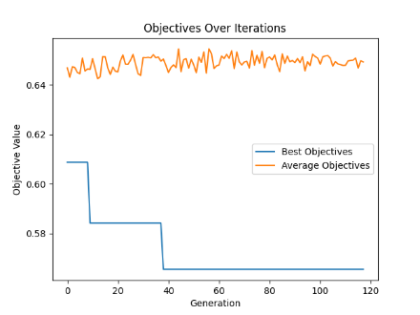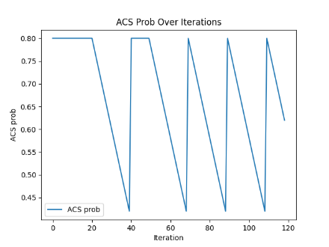

cl_06_060_02:

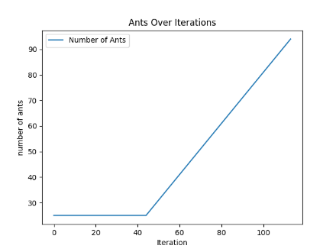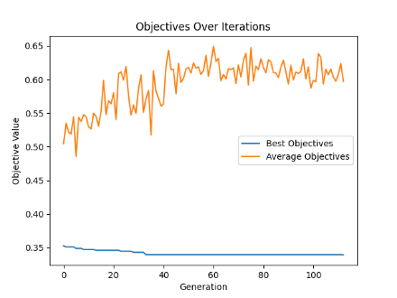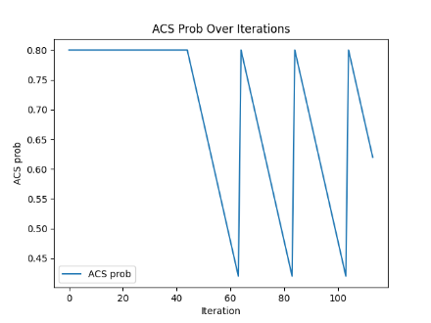

cl_06_080_01:

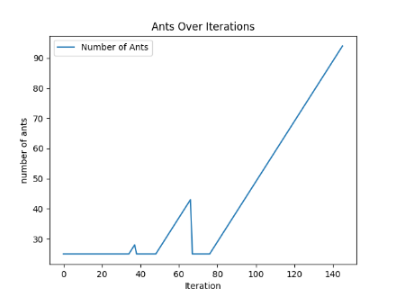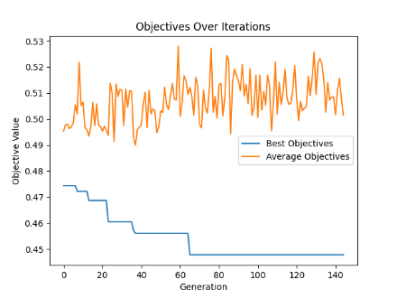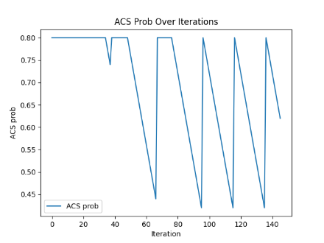

cl_06_100_10:

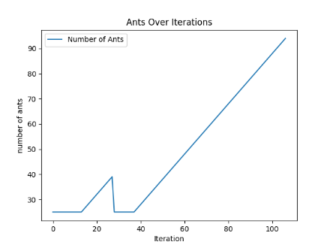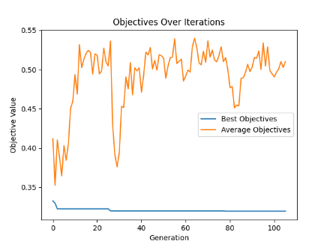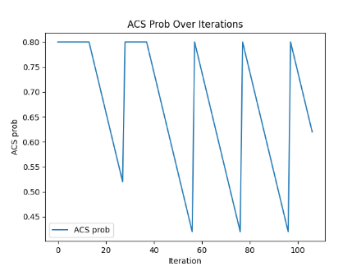

cl_07_020_08:

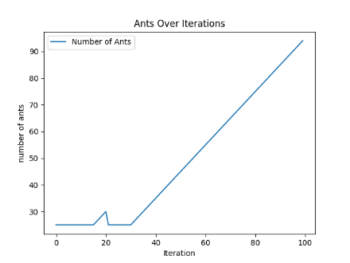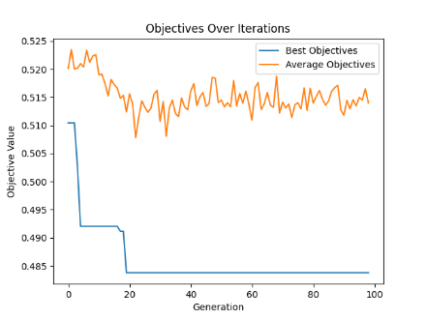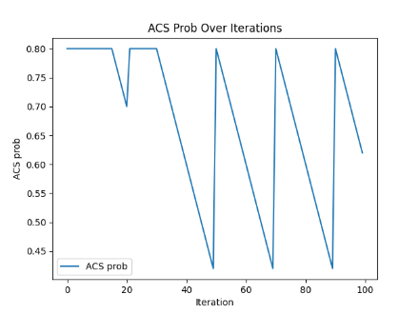

cl_07_040_06:

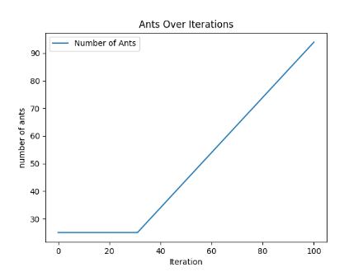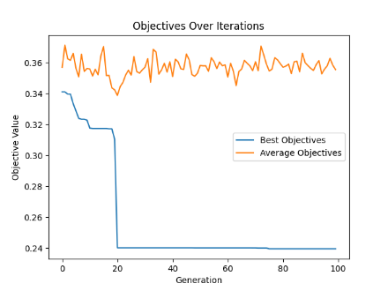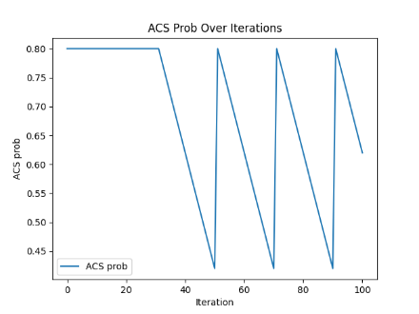

cl_07_060_05:

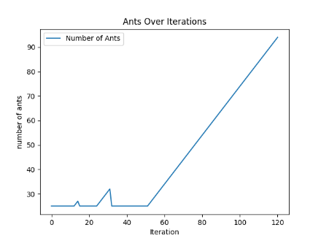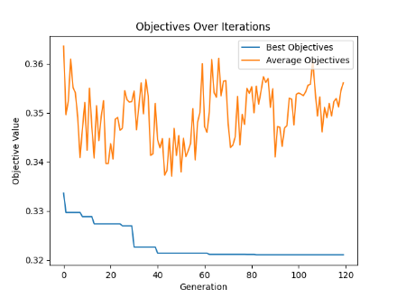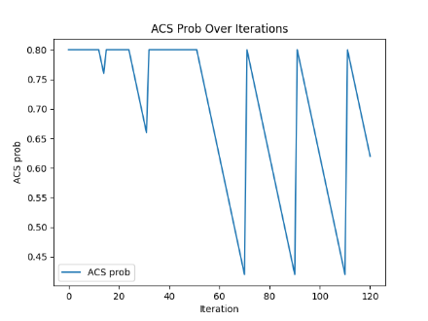

cl_07_080_08:

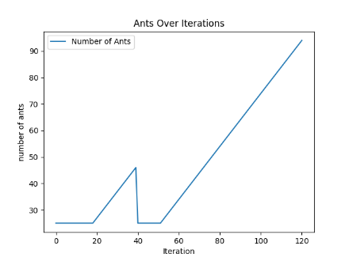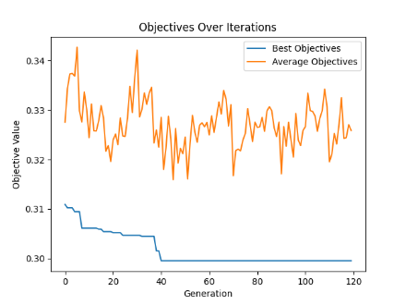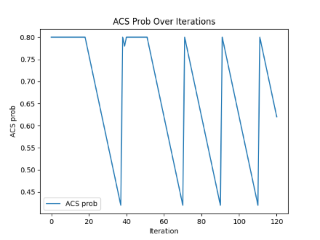

cl_07_100_10:

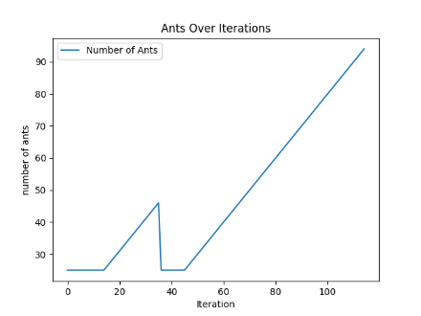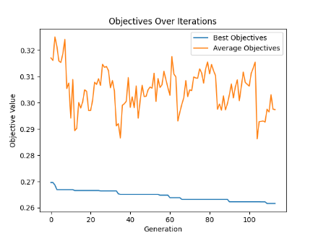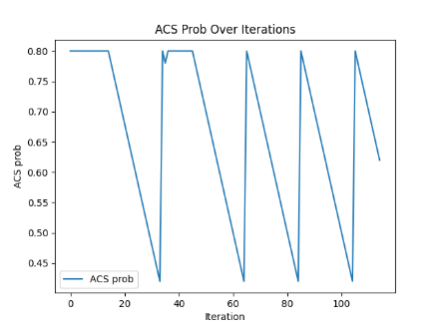

cl_08_020_05:

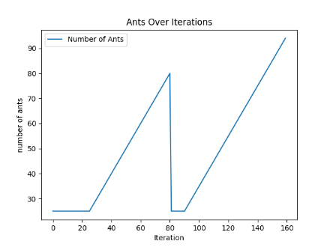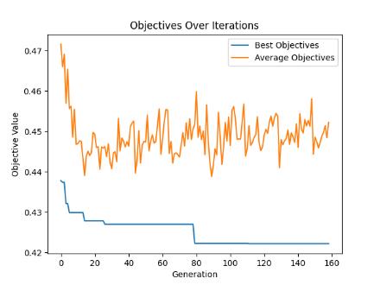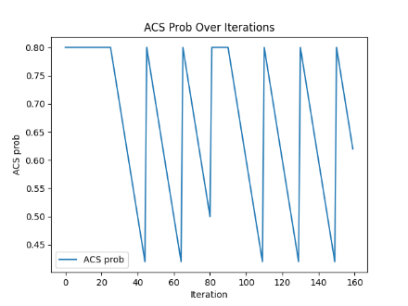

cl_08_040_03:

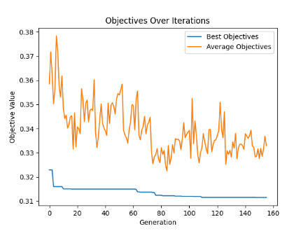

cl_08_060_05:

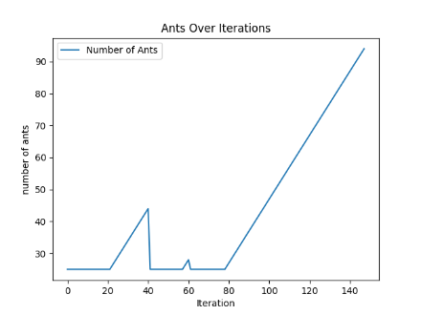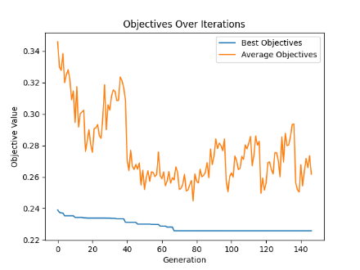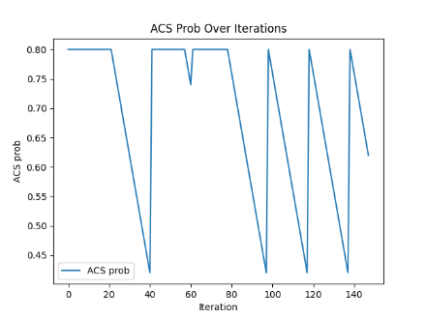

cl_08_080_07:

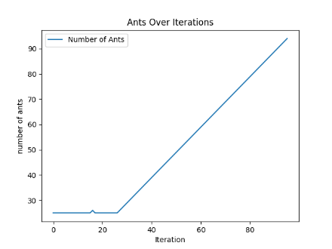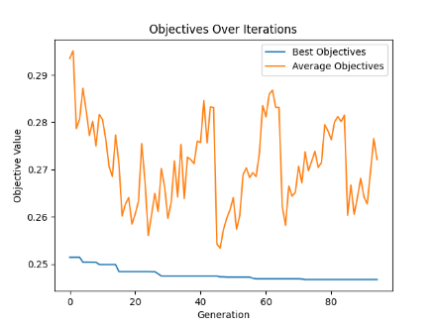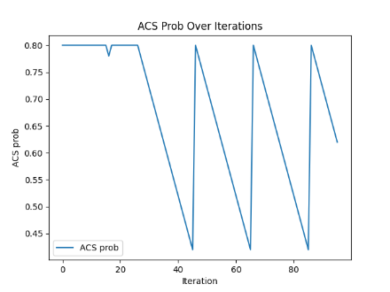

cl_08_100_03:

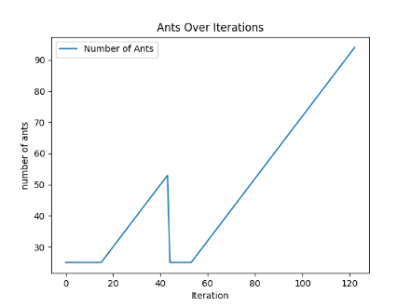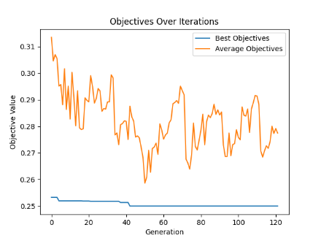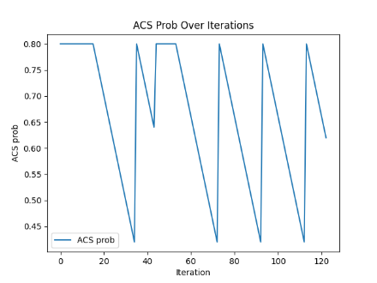

cl_09_020_04:

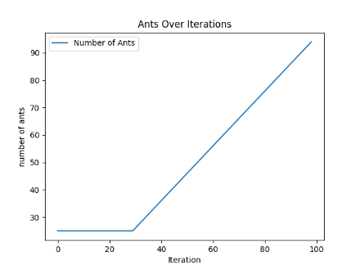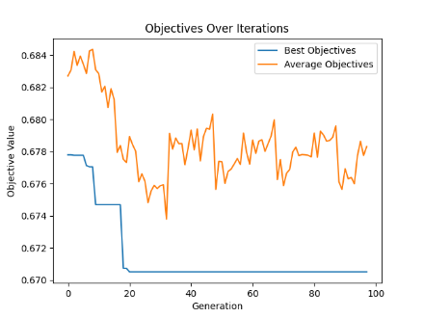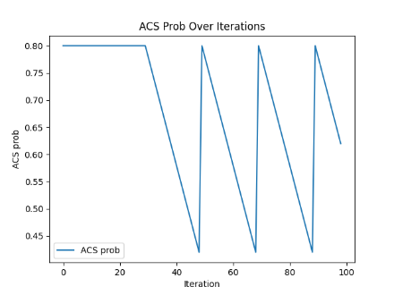

cl_09_40_10:

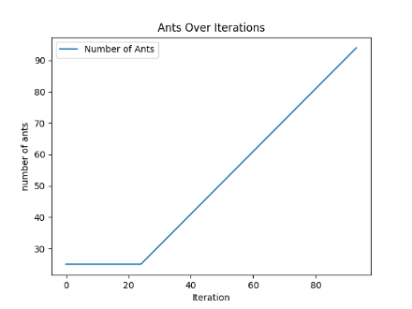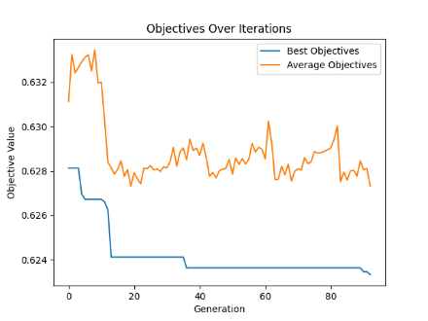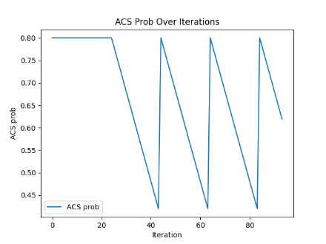

cl_09_060_07:

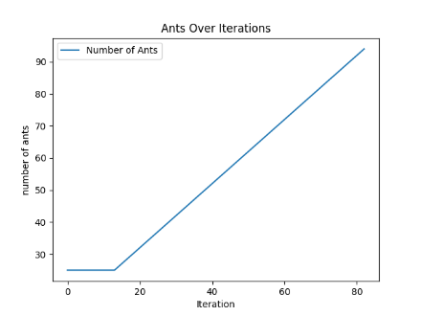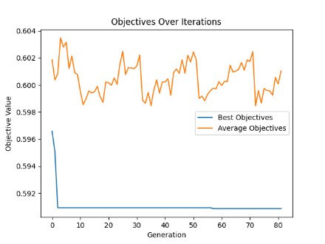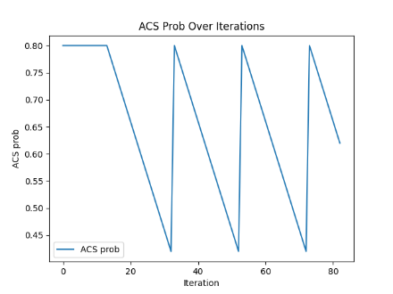

cl_09_080_04:

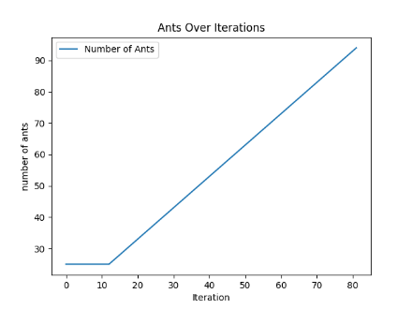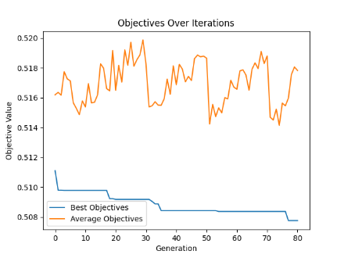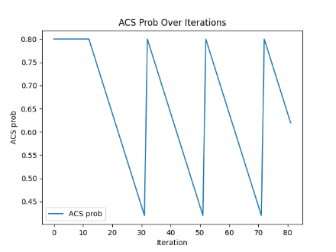

cl_09_100_05:

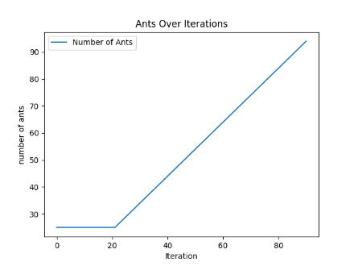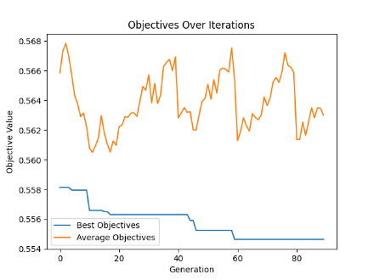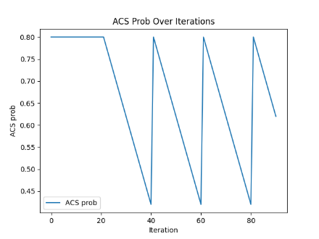

cl_10_020_08:

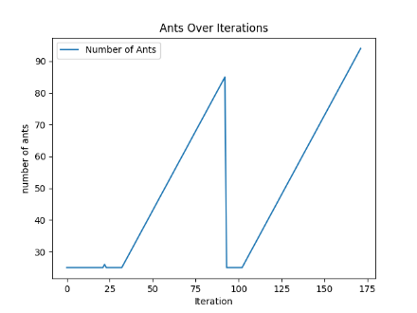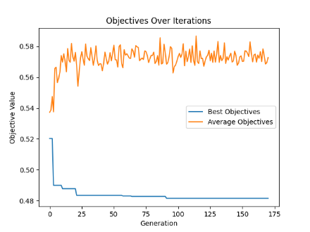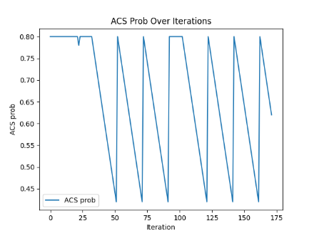

cl_10_040_03:

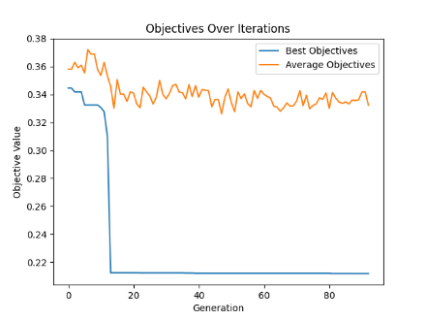

cl_10_060_05:

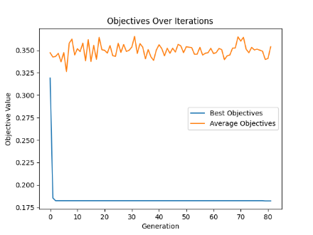

cl_10_080_02:

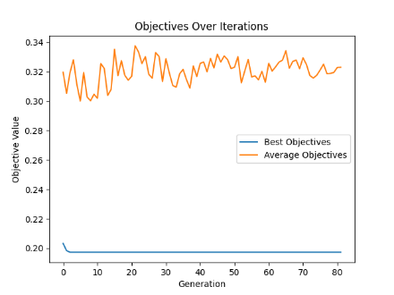

cl_10_100_04:

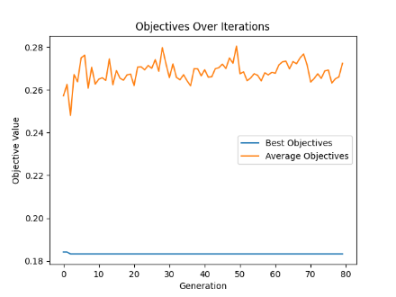

Discussion:

1. Alpha- This parameter controls the influence of the pheromone trail on the probability of selecting a path. A higher alpha increases the relative importance of pheromone levels, which enhances exploitation by encouraging ants to follow stronger pheromone trails more frequently. This can potentially lead to premature convergence if too high.

2. Beta - This parameter governs the influence of the heuristic information (which is placing items in a bin with fewer available space). A higher beta encourages exploration by making the path choice more sensitive to the heuristic desirability of the move, thus reducing the risk of premature convergence.

3. Evaporation Rate - Pheromone evaporation helps in avoiding premature convergence by reducing the pheromone trail left on all paths over time, which prevents the solution from getting stuck in a local optimum. A higher evaporation rate increases exploration by decreasing the pheromone influence more rapidly.

4. Ant Count - The number of ants used in each iteration of the algorithm influences exploration; more ants allow for the simultaneous investigation of more potential solutions (paths). However, it is also important to use a method that discourages excessive state transitions based on greediness.

8. Max Pheromone and Min Pheromone - These parameters set the upper and lower bounds for pheromone levels on paths. Limiting the maximum pheromone level can prevent overly strong trails that lead to premature convergence, while the minimum level ensures that no path is entirely forsaken, supporting exploration.

9. ACS State Transition Probability - Specifically used in Ant Colony System (ACS), a variant of ACO, this probability determines how often ants choose the next item based on a probabilistic rule versus the best option (exploitation vs. exploration). A higher value promotes exploitation by more frequently choosing the best available option.

Conclusion:

The application of the Ant Colony Optimization (ACO) algorithm to the 2D bin packing problem has demonstrated significant promise in addressing one of the more challenging issues in combinatorial optimization. Throughout our study, ACO's nature-inspired mechanisms have shown their potential to effectively mimic the foraging behavior of ants, enabling the discovery of efficient packing strategies within a computationally feasible timeframe. The results obtained from numerous iterations and configurations have highlighted the adaptive nature of ACO, particularly in its ability to balance exploration and exploitation through parameters such as the number of ants, pheromone evaporation rate, and the alpha and beta values.

The variation in the number of bins used across different test cases reinforces the algorithm's sensitivity to initial conditions and parameter settings, underscoring the importance of fine-tuning these parameters to optimize performance. The exploration facilitated by adjusting the ACS state transition probability has further enhanced the algorithm's efficiency, leading to more consistent results across runs.

Compared to PSO, ACO is slow in decreasing number of Bins from initial solution. (with same initialization method)

1. Nguyen, T.-H., & Nguyen, X.-T. (2023). Space Splitting and Merging Technique for Online 3-D Bin Packing. Mathematics, 11(1912), 1-16. <https://doi.org/10.3390/math11081912>
2. Ducatelle, F., & Levine, J. (2002). Ant Colony Optimisation for Bin Packing and Cutting Stock Problems. Informatics Research Report EDI-INF-RR-0101, Division of Informatics, University of Edinburgh. Retrieved from <http://www.informatics.ed.ac.uk/>
3. Wang, S., Shi, R., Wang, L., & Ge, M. (2010). Study on Improved Ant Colony Optimization for Bin-Packing Problem. In Proceedings of the 2010 International Conference on Computer Design and Applications (ICCDA 2010) (Vol. 4, pp. 489-491). IEEE.